## **Parking lot USB exercise**

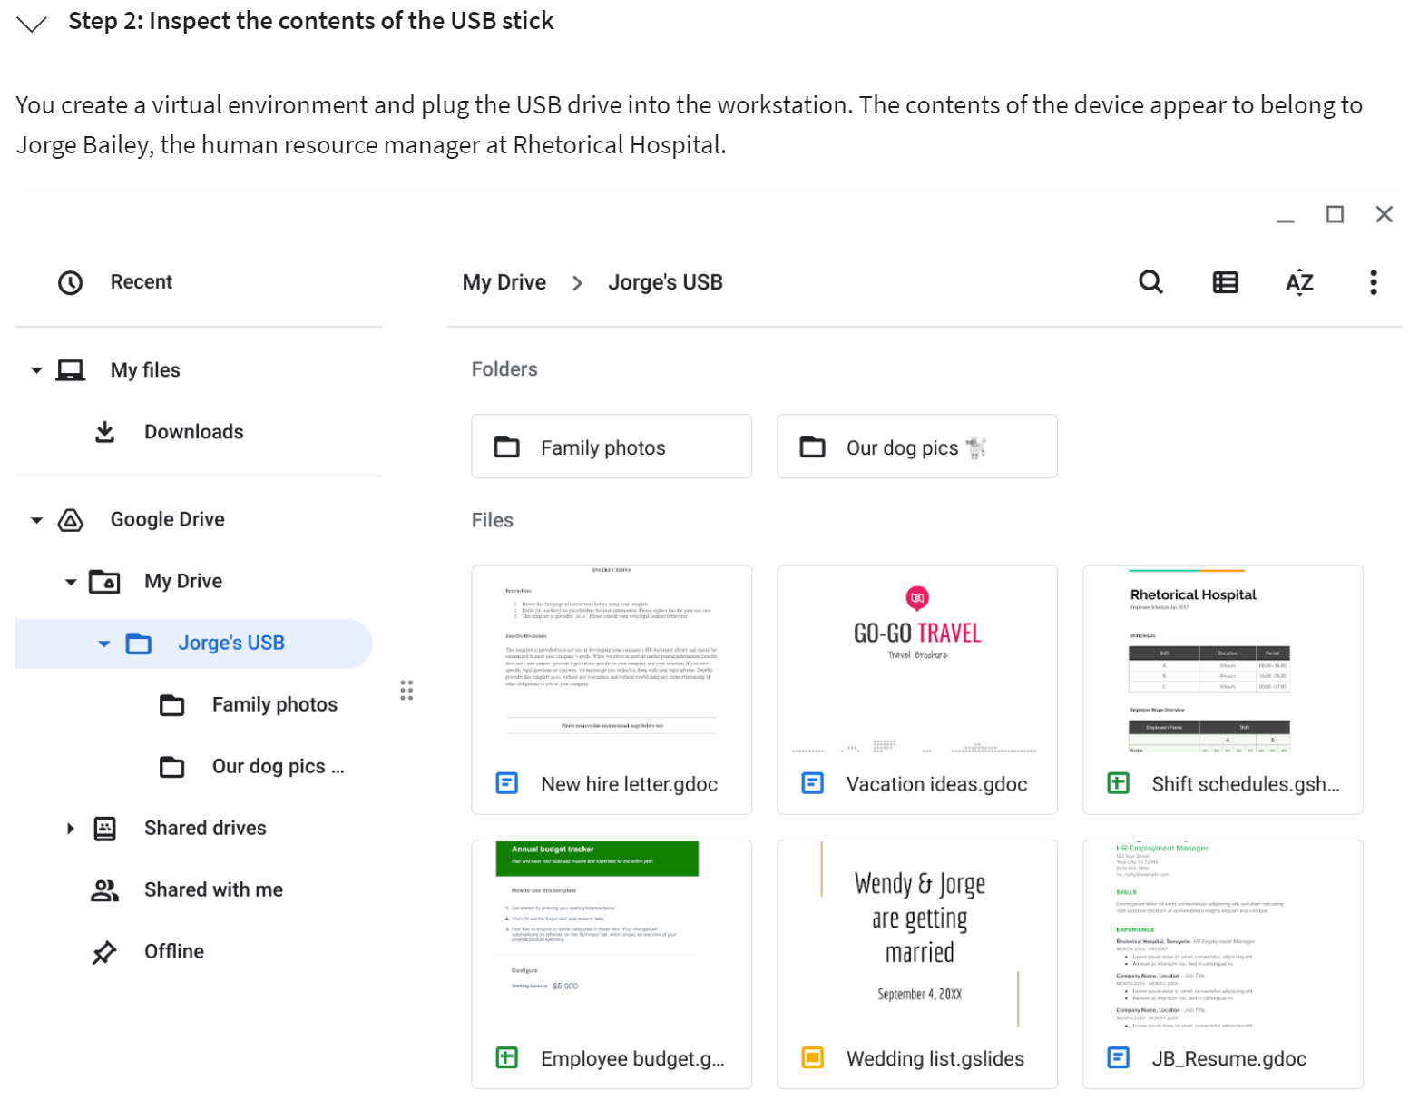

|  |  |
| --- | --- |
| **Contents** | Write **2-3 sentences** about the types of information found on this device.  *There are some files that contain PII, of the owner, but also of other people. There are also files containing information about hospital’s operations.* |
| **Attacker mindset** | Write **2-3 sentences** about how this information could be used against Jorge or the hospital.  *The shift schedules could provide information of the people Jorge works with. Social engineering could be used by a malicious actor, pretending to be a co-worker and asking for private data from Jorge.* |
| **Risk analysis** | Write **3 or 4 sentences** describing technical, operational, or managerial controls that could mitigate these types of attacks:  *Enhancing employee awareness about the risks associated with suspicious USB drives is a crucial managerial control that helps mitigate the risk of security incidents. Implementing regular antivirus scans serves as an operational control to detect and address potential threats. Additionally, a technical control such as disabling AutoPlay on company PCs can further protect against automatic execution of malicious code when a USB drive is inserted.* |